Evaluation Question I
To what extent will the Hmong Helping Hands Intervention participants show reductions in stress?
Outcome Measures
About how often during the past 30 days did you feel… | All of the  time | Most of the time | Some of the time | A little of the time | None of the time
- … nervous?
- … hopeless?
- … restless or fidgety?
- … so depressed that nothing could cheer you up?
- … feel that everything was an effort?
- … worthless?

Instructions: The next questions are about how you have been feeling during the past 30 days.

1. Changes in levels of Nervousness. Pre-34. Post-9
2. Changes in levels of Hopelessness. Pre-35. Post-10
3. Changes in restless or fidgety everything was an effort. Pre-36. Post-11
4. Changes in Depressing Feeling that nothing could clear you up? Pre-37. Post-12
5. Changes in feeling that everything was an effort. Pre-38. Post- 13
6. Changes in level of worthlessness. Pre-34. Post-14

A Paired Samples T-Test was conducted using JASP to compare mean stress level ratings across six discriminatory fields for The Fresno Center.
Paired Samples T-Test
Participants were asked how they were feeling during the past 30 days.

NERVOUS …nervous?
HOPELESS … hopeless?
RESTLESS ... restless or fidgety?
DEPRESSED... depressed nothing could cheer you up.
EFFORTFUL. . . feel that everything was an effort
WORTHLESS . . . worthless?

The participants were given surveys before and after their active involvement in The Fresno Center. The results indicate there is a significance between five of the six areas observed, RESTLESS had a p-value of .156 >.05 therefore the results were considered invalid for RESTLESS.

NERVOUS
There was a significant difference in participant’s reported levels of Nervousness before (M=2.333, SD=1.267) and after activity involvement at the Fresno Center (M=3.041, SD=1.224) conditions; t (-4.563) =114, 97, p<.001
HOPELESS
There was a significant difference in participant’s reported levels of Hopelessness before (M=2.526, SD=1.416) and after activity involvement at the Fresno Center (M=3.309, SD=1.167) conditions; t (-4.525) =114, 97, p<.001.
RESTLESS
There was no significant difference found in participant’s reported levels of Restlessness before (M=2.789, SD=1.201) and after activity involvement at the Fresno Center (M=3.021, SD=1.275) due to an invalid p-value. conditions; t (-1.535) =114, 97, p<.128.
DEPRESSED
There was a significant difference in participant’s reported levels of Depression before (M=2.439, SD=1.290) and after activity involvement at the Fresno Center (M=3.330, SD=1.491) conditions; t (-5.542) =114, 97, p<.001.
EFFORTFUL
There was a significant difference in participant’s reported levels of Effort required in completing tasks before (M=1.991, SD=1.285) and after activity involvement at the Fresno Center (M=3.062, SD=1.485) conditions; t (-4.920) =114,97, p<.001.
WORTHLESS
There was a significant difference in participant’s reported levels of Worthlessness before (M=2.770, SD=1.458) and after activity involvement at the Fresno Center (M=3.309, SD=1.453) conditions; t (=3.067) =113,97 p<.003.
Descriptive Plots
PRENERVOUS – POSTNERVOUS PREHOPELESS - POSTHOPELESS
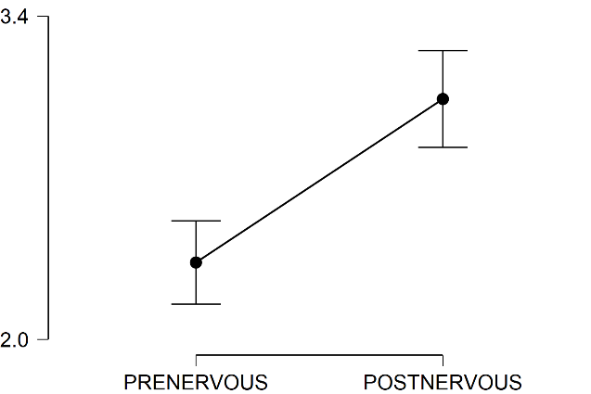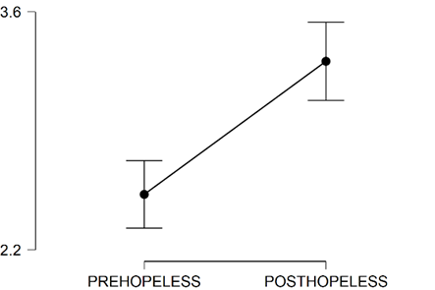

PRERESTLESS – POSTRESTLESS PREDEPRESSED - POSTDEPRESSED
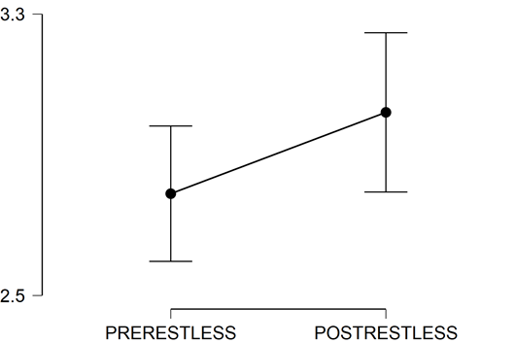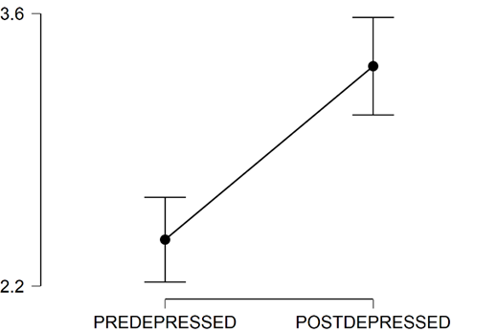
PREWORTHLESS – POSTWORTHLESS PREEFFORTFUL - POSTEFFORTFUL
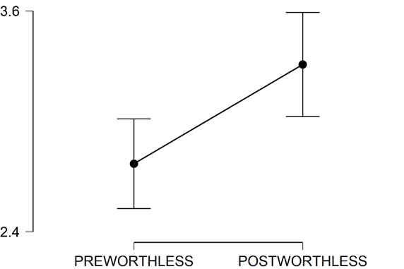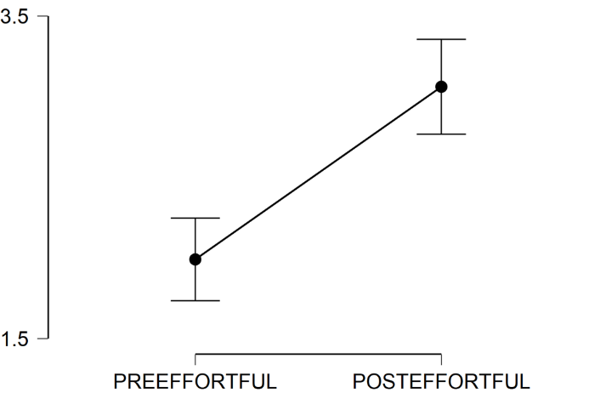

Evaluation Question II
To what extent will the Hmong Helping Hands participants physically, psychologically, and spiritually strengthen?
Outcome Measures
1.Changes in how a religious person feels. Changes in how a person Feels about their culture. Pre-5 Post-5 CULTUREFEELING
About how often during the past 30 days did you feel… | All of the  time | Some of the time | None of the time
5.…connected to your culture?

2. Changes in the importance of Religion. Pre-4 Post-4 RELIGIOUSIMPORTANCE
4.You feel connected to the spiritual/religious traditions of the culture you were raised in.

3. The extent his/her life is balanced physically, emotionally, mentally, and spiritually. Pre-6 Post-6 MINDBODYSPIRIT
6.…balanced in mind, body, spirit and soul?

4. The extent that a person feels he/she is drawing strength from his/her own culture. Pre-1 Post-1 CULTURESTRENGTH

- Your culture gives you strength.

5. Changes in the importance of culture. Pre-2 Post-2 CULTUREIMPORTANCE
2. Your culture is important to you.

6.Changes of how culture affect emotions. Pre-3 Post-3 CULTUREEMOTION
3. Your culture helps you to feel good about who you are.

A Paired Samples T-Test was conducted using JASP to compare mean physical, psychological, and spiritual level ratings across five discriminatory fields for The Fresno Center.
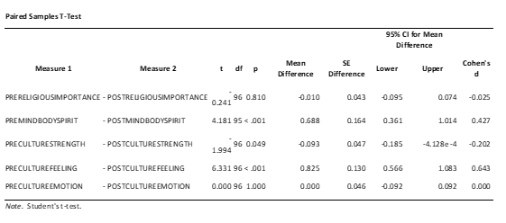
Participants were asked how they were feeling during the past 30 days.

RELIGIOUSIMPORTANCE You feel connected to the spiritual/religious traditions of the culture which you were raised in.
MINDBODYSPIRIT… balanced in mind, body, spirit, soul.
CULTURESTRENGTH Your culture gives you strength.
CULTUREFEELING... connected to your culture?
CULTUREEMOTION Your culture helps you to feel good about who you are.

The participants were given surveys before and after their active involvement in The Fresno Center. The results indicate there is a significance between three of the five areas observed, RELIGIOUSIMPORTANCE had a p-value of .810>.05, and CULTUREFEELING had a p-value of1.00.>.005 therefore the results were considered invalid for both RELIGIOUSIMPORTANCE and CULTUREEMOTION.
RELIGIOUSIMPORTANCE
There was no significant difference found in participant’s reported levels of Importance of religion before (M=2.123, SD=0.355) and after activity involvement at the Fresno Center (M=2.1344, SD=.399) due to an invalid p-value. conditions; t (.241) =114, 97, p<.810.
MINDBODYSPIRIT
There was a significant difference in participant’s reported levels of strengthening the mind, body, and spirit before (M=2.681, SD=1.270) and after activity involvement at the Fresno Center (M=2.052, SD=1.084) conditions; t (4.181) =113, 97, p<.001.
CULTURESTRENGTH
There was a significant difference in participant’s reported levels of feeling cultural strength before (M=2.088, SD=.314) and after activity involvement at the Fresno Center (M=2.165, SD=.400) conditions; t (1.994) =114, 97, p<.049.
CULTUREFEELING
There was a significant difference in participant’s reported levels of feeling culturally involved required in completing tasks before (M=2.351, SD=1.175)and after activity involvement at the Fresno Center (M=1.515, SD=0.925) conditions; t (6.331) =114,97, p<.001.
CULTUREEMOTION
There was no significant difference found in participant’s reported levels of emotional involvement to their culture before (M=2.079, SD=.0302) and after activity involvement at the Fresno Center (M=2.082, SD=0.312) due to an invalid p-value. conditions; t (0.000) =114, 97, p=1.00.
Descriptive Plots
PRERELIGIOUSIMPORTANCE- PREMINDBODYSPIRIT-
POSTRELIGIOUSIMPORTANCE POSTMINDBODYSPIRIT

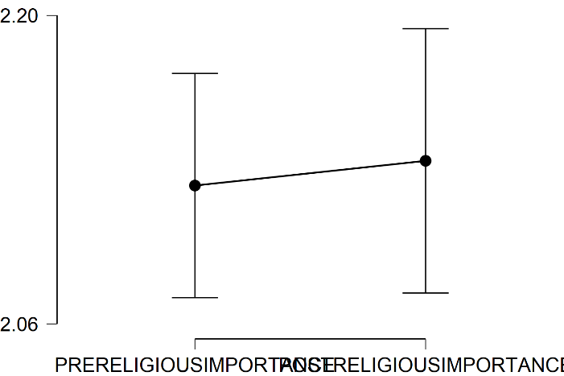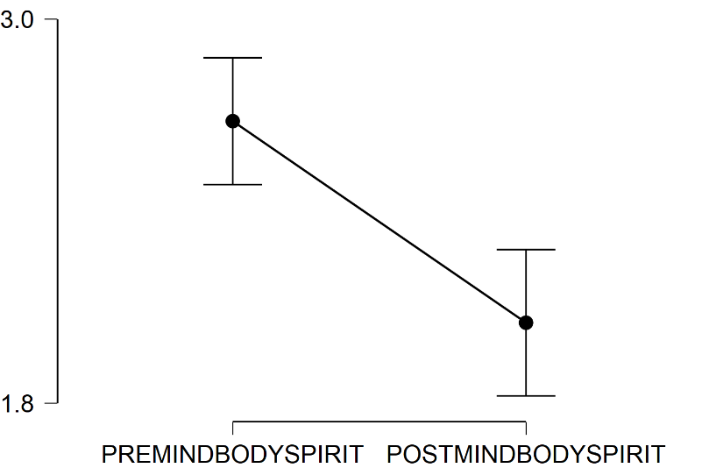
PRECULTURESTRENGTH- PRECULTUREFEELING-
POSTCULTURESTRENGTH PRECULTUREFEELING
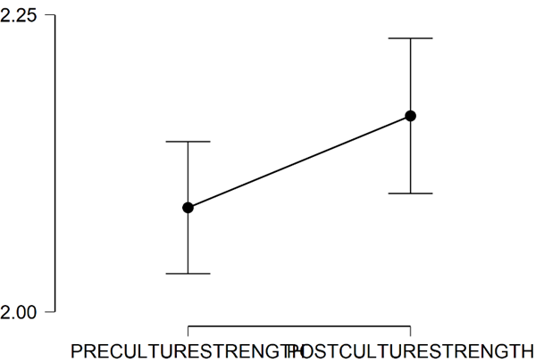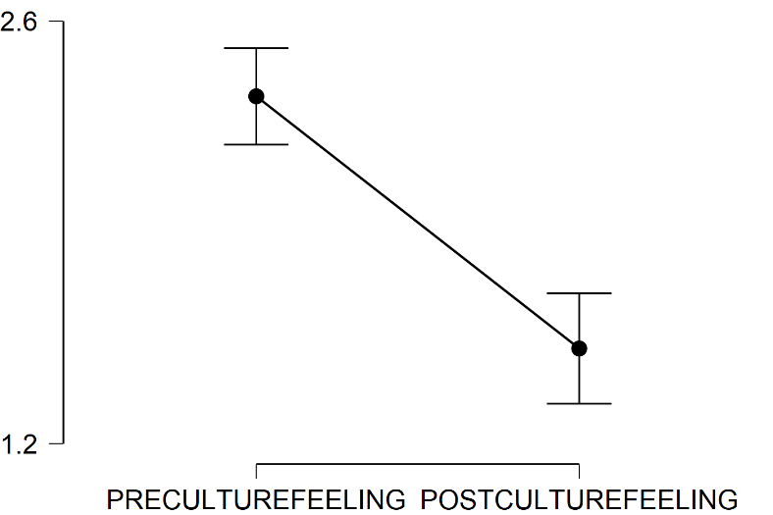
PRECULTUREEMOTION-
POSTCULTUREEMOTION
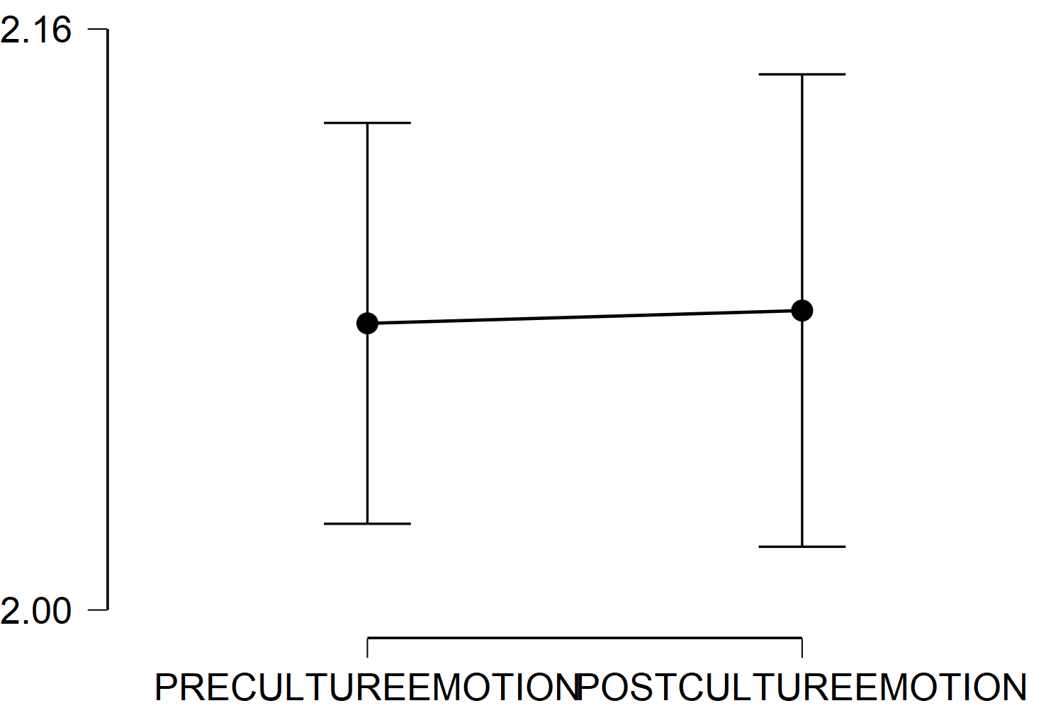

Evaluation Question III
To what extent will the Hmong Helping Hands participants sense of belonging strengthen?
Outcome Measures
1. Changes in Feeling marginalization or exclusion from society. Pre 7 Post-7 MARGINILIZATION
2. Changes in Feeling of isolation and alienation from society. Pre-8 Post-8 ISOLATION
7.…marginalized or excluded from society?
(In other words, made to feel unimportant, or like your thoughts, feelings, or opinions don’t matter.)
8…isolated and alienated from society?
(In other words, feeling alone, separated from, cut off from the world beyond your family, school, and friends.)

3. Attitude Towards changes about friendship Pre-43 Post-18 FRIENDATTITUDE (Thrown Away Question due to invalid Data)
43.…social life?

4. Attitude changes about doing things with others Pre-41 Post-16 INVOLVEDATTITUDE
- …performance at work or school?

5. Changes in feeling about belonging to a community Pre-44 Post-19 BELONGING (Thrown Away Question due to invalid Data)
44.…relationship with friends and family?

A Paired Samples T-Test was conducted using JASP to compare mean sense of belonging ratings across three discriminatory fields for The Fresno Center.

Participants were asked how they were feeling during the past 30 days.

MARGINALIZATION. . . marginalized or excluded from society? (In other words, made to feel unimportant, or like your thoughts, feelings, or opinions don’t matter.)
ISOLATION…isolated and alienated from society? (In other words, feeling alone, separated from, cut off from the world beyond your family, school, and friends.)
INVOLVEDATTITUDE…performance at work or school?

The participants were given surveys before and after their active involvement in The Fresno Center. The results indicate there is a significance between three of the three areas observed,

MARGINILIZATION
There was a significant difference in participant’s reported levels of feeling marginalized before (M=3.071, SD=1.307) and after activity involvement at the Fresno Center (M=3.722, SD=1.477) conditions; t (3.933) =113, 97, p<.001.
ISOLATION
There was a significant difference in participant’s reported levels of feeling isolated before (M=3.509, SD=.1.352) and after activity involvement at the Fresno Center (M=3.928, SD=.1.445) conditions; t (2.284) =114, 97, p<.025.
INVOLVEDATTITUDE
There was a significant difference in participant’s reported levels of work and school involvement before (M=1.726, SD=.468) and after activity involvement at the Fresno Center (M=1.969, SD=0.488) conditions; t (4.359) =113,97, p<.001.
Descriptive Plots
PREMARGINILIZATION- PREISOLATION-POSTISOLATION
POSTMARGINILIZAIION
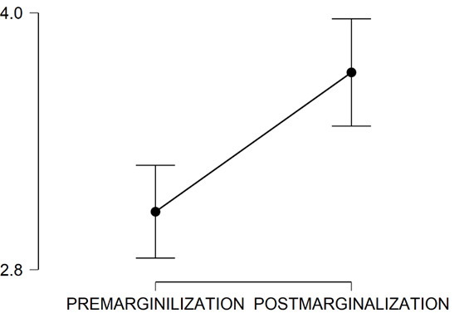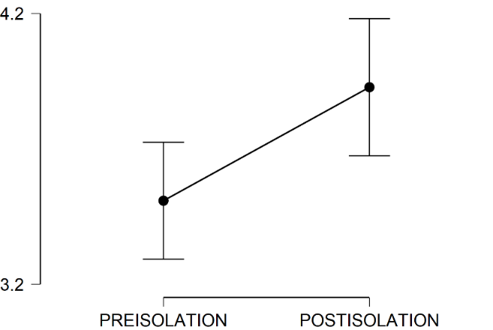
PREINVOLVEDATTITUDE- POSTINVOLVEDATTITUDE
